LAB EXPERIMENT 2
1. Create database CMS;
2. drop database CMS;
3. rename database CMS>CMS1;
4. Use database CMS;
5.show tables;

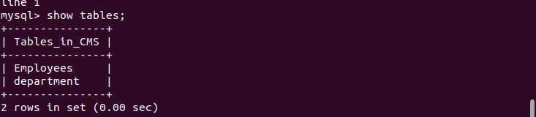

LAB EXPERIMENT 3
1. CREATE table department(Department_ID int primarykey, Name char(20), num int, ManagerID number(4) foreignkey references Employee(EMP_ID), Startdate date, location varchar(30));

CREATE table department(Department_ID varchar(20) primary key, Name char(20), Number varchar(10), ManagerID varchar(4), Startdate date, location varchar(30));

create table department(dept_id varchar(10) PRIMARY KEY, Name varchar(20), num varchar(12),ManagerID varchar(4),start_date date, location varchar(30));

2.create table Project(ProjectID varchar(5) PRIMARY KEY, Name varchar(20),
num varchar(12), Location varchar(40), DeptID varchar(5);
3.cretae table employees(EMPID Varchar(5) PRIMARY KEY, Name varchar(20), SSN int, salary decimal(10,4), Gender varchar(5), Birthdate date, Department_ID varchar(5), Supervisor_ID varchar(5);

4.create table projectassignment(assignmentId varchar(10), EmployeeID varchar(5) foreign key refernces Employee(emp_id),hpw varchar(4));

5.create table dependandt(dependantId varchar(10), EmpID varchar(5) foreign key references Employee(emp_id), Firstname varchar(10), Gender varchar(6),b_date date, relationship varchar(10));

6.

Experiment 4:

insert into employees values(1,”a”,”200”,”100.2”,”male”,”24-JAN-2001”,”2000”,”2000”);
insert into projectassignment values(“1”,”1”,”200”);
insert into dependant values(1,”1”,”200”,”a”,”male”,”24-JAN-2001”,”SPOUSE”);
insert into project values(“1”,”a”,”200”,”ern”,”200”);
insert into department(“1”,”a”,

